Dictionary Management System

User Guide
V2.16.1

Table of Contents

1. Getting started 4
1.1 Overview 4
1.2 Access DMS 4
1.3 Getting support 4
1.4 Roles and Privileges 5
1.5 Views 6
2. Managing products & applications 8
2.1 Product tree 8
2.2 Create a new product 8
2.3 Delete a product 9
2.4 Add a product version 9
2.5 Delete a product version 10
2.6 Create a new application 11
2.7 Delete an application 11
2.8 Add an application version 12
2.9 Delete an application version 13
2.10 Manage application list of a versioned product 14
3. Delivering application dictionaries 17
3.1 Supported dictionary formats 17
3.2 Prepare dictionary package 19
3.3 Upload dictionary files 19
3.4 Change language settings 21
3.5 Change string settings 21
3.6 Add/Edit/Delete labels 22
3.7 About context 23
3.8 Errors and warnings 24
3.9 Import dictionaries 25
3.10 Update existing dictionaries 27
3.11 Add new language to dictionaries 27
3.12 Delete dictionaries 28
3.13 Search reference text 29
3.14 Capitalize labels 31
4. Managing translations 33
4.1 View translation summary and details 33
4.2 Update translation and status 34
4.3 View translation history 35
4.4 Export and import translations 36
4.5 Create a translation task 38
4.6 Download a translation task 39
4.7 Translation task file structure 39
4.8 Upload translation results 40
4.9 Close a translation task 42
5. Exporting application dictionaries 43
6. Settings 44
6.1 Glossary 44
6.2 Reference Translation 44
7. External Web APIs 46
7.1 Overview 46
7.2 Generating dictionary from DMS 46
7.3 Delivering dictionary into DMS 46

Getting started

Overview
Software applications are generally localized so that they can be used by people of different languages (aka L10N). Translating strings in application into different languages is a major and the most important step of the localization process. Normally the strings are put into one or several resource files which we say application dictionaries. Application dictionaries can be various, based on application design, software architecture, development technology, and so on.
Dictionary Management System (DMS) is a dictionary & translation management tool which aims at providing a unified and efficient platform for the localization of application dictionaries.

Access DMS
DMS is a web application accessible through ALU intranet. Links to DMS environment can be found in DMS home page:
http://aww.rdcsbu.bsf.alcatel.fr/tools/dms
Supported browsers:
- Internet Explorer 7+
- Mozilla Firefox 3.x+
- Google Chrome 2.x+

Getting support
If you have any request/suggestion on DMS, or you find any bug/issue, you can create a ticket in OSP (Operation Service Portal). The link is below the login page:
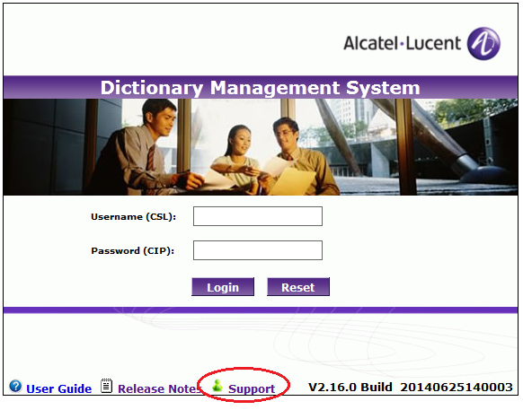
We’ll keep you informed any progress on your ticket.

Roles and Privileges
There are several types of role defined in DMS. Every visitor who has a valid CSL account logs in as Guest role by default.
Guest
Guest is default role for all visitors. Guests have read-only access of all items. They can browse dictionaries, view translations, download files, and so on. But they cannot make any change to existing dictionaries and translations.
Application owner
Application owner is the provider of application dictionaries to be translated. Application owners have write access of their dictionaries and associated translations*.
* In current version, application owner has write access of all dictionaries regardless of their owner.
Translation manager
Translation manager is the interface between application owner and translator, and is responsible to manage the whole translation procedure. Translation manager has write access of translation tasks and translation status.
Administrator
Administrator has all privileges, and is responsible to maintain master data such as languages, charsets, and change role of users as well.

Functionality | Application owner | Translation manager | System administrator
Manage product/version | Y | Y | Y
Manage application/dictionary | Y | Y | Y
Import application dictionary | Y |  | Y
Export application dictionary | Y | Y | Y
Create translation task |  | Y | Y
Send for translation |  | Y | Y
Receive translation |  | Y | Y
Generate translation summary report | Y | Y | Y
Add new language to dictionary | Y | Y | Y
Access control |  |  | Y
Language code & charset definition |  |  | Y

Views
There are 4 main views in DMS: Dictionary Management, Translation Management, Task Management and Administration. After log in DMS, user can switch between them via view navigator at top of the page:
Dictionary Management view is mainly used by application owner to deliver and modify application dictionaries.
Translation Management view is mainly used by translation manager to create translation tasks and to adjust translation status.
Task Management view is mainly used by translation manager to export translation tasks and import translation results.
Administration view is used by administrator to maintain master data and user privileges.

Managing products & applications

Product tree
On the left side of “Dictionary Management” view, there is a product tree. Products are represented as the first level in the tree and applications are put into the tree as child nodes of their parent products.
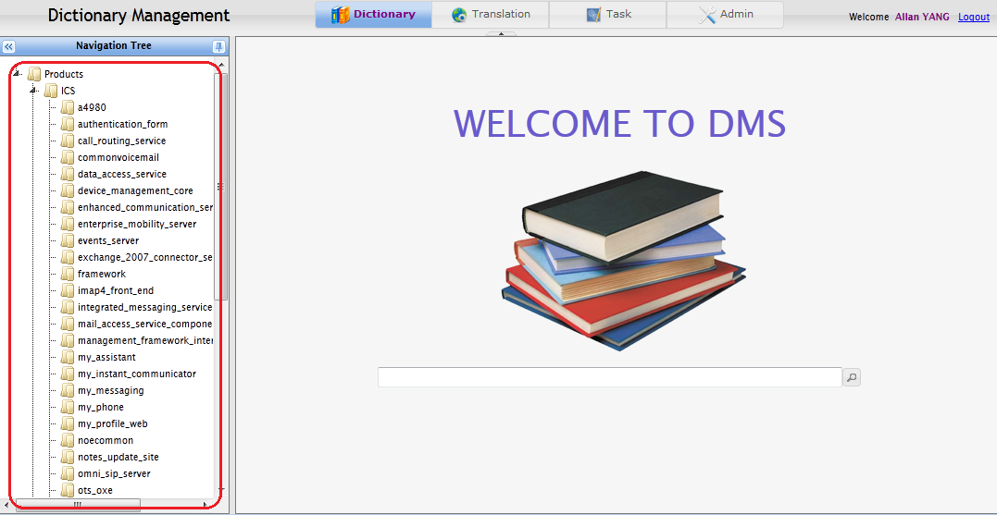

Create a new product
Right click root node of product tree and select “New product” in context menu. Then enter the product name and hit return.
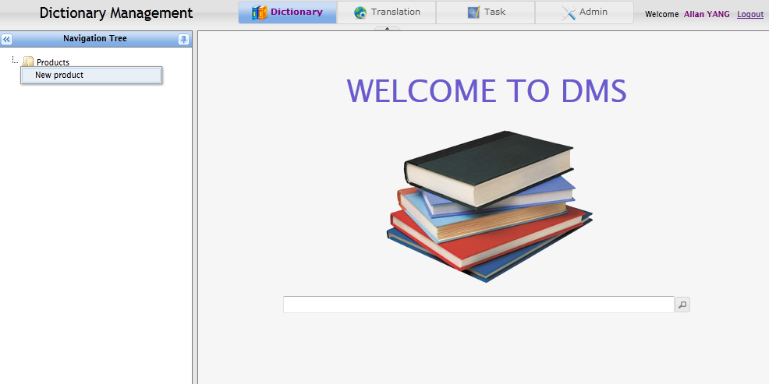

Delete a product
Right click the product name to be deleted, and select “Delete product” in context menu.
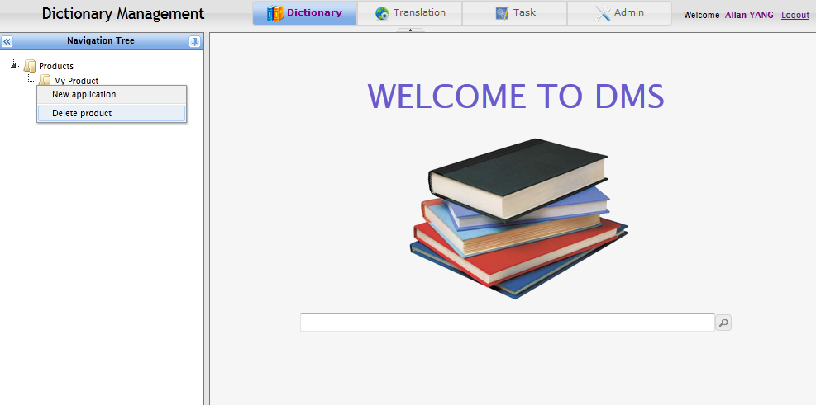
Note: Only empty product can be deleted, which means you must delete all product versions and underlying applications before you delete a product.

Add a product version
Click the product name, then product version list and application list will be displayed on the right side. Click “+” button to add a product version.
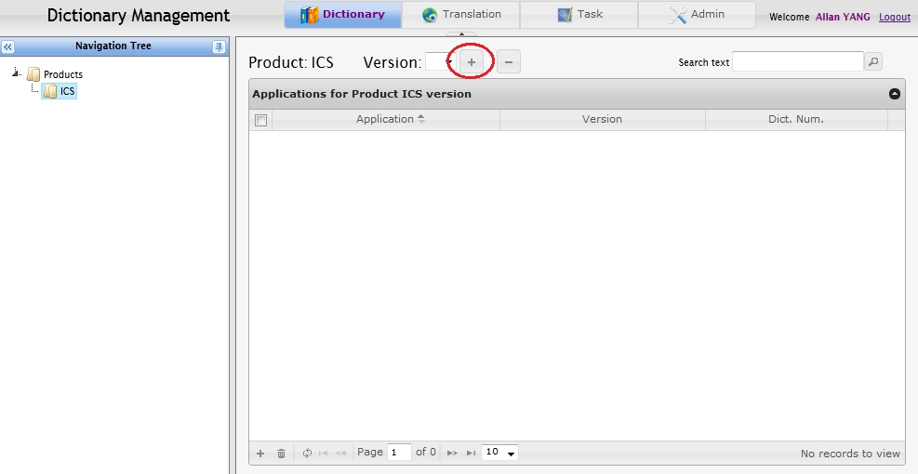
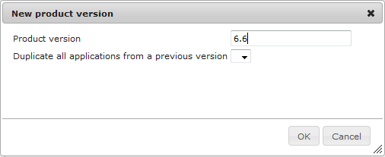
In the popup dialog, enter a version number, and select a previous version from which you want to copy applications into the new version. For instance, you may want to copy all existing applications in ICS 6.6 as a start point when you create a new version 6.7. You can also create an empty version without copy applications from any of the previous versions.

Delete a product version
Click “-” button next to version list to delete the version currently selected.
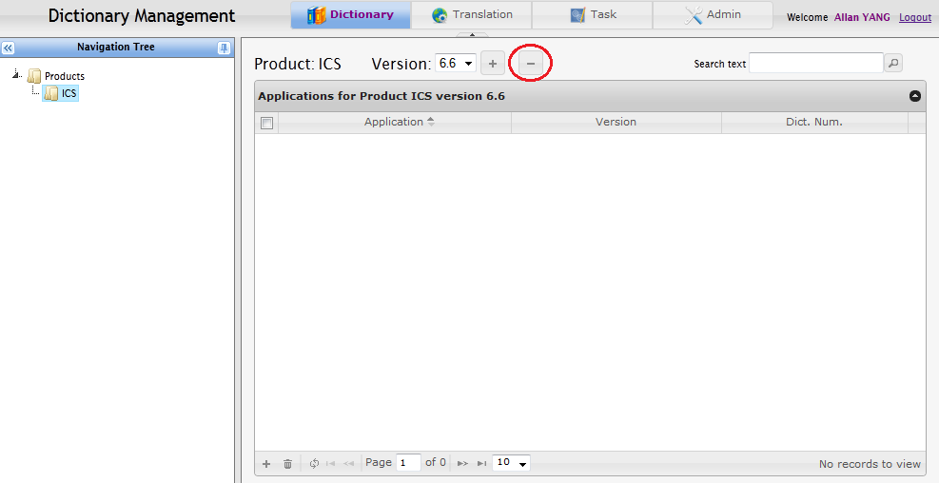
Note: Only empty product version can be deleted, which means you must remove all underlying applications before you delete a product version.

Create a new application
Right click a product name, and select “New application” in context menu. Then enter the application name and hit return.
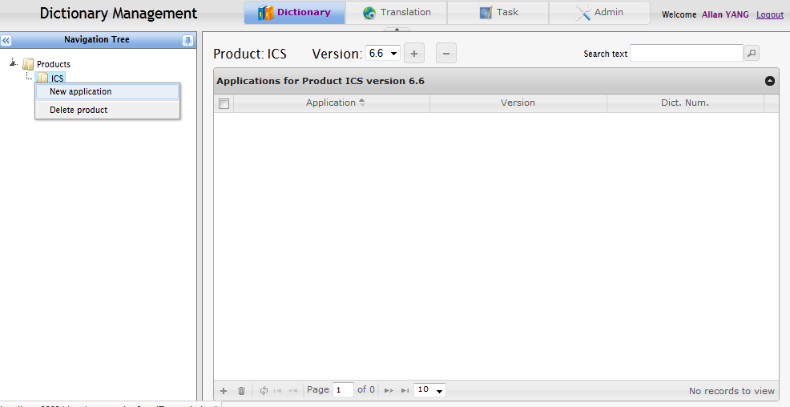

Delete an application
Right click the application name and select “Delete application” in context menu.
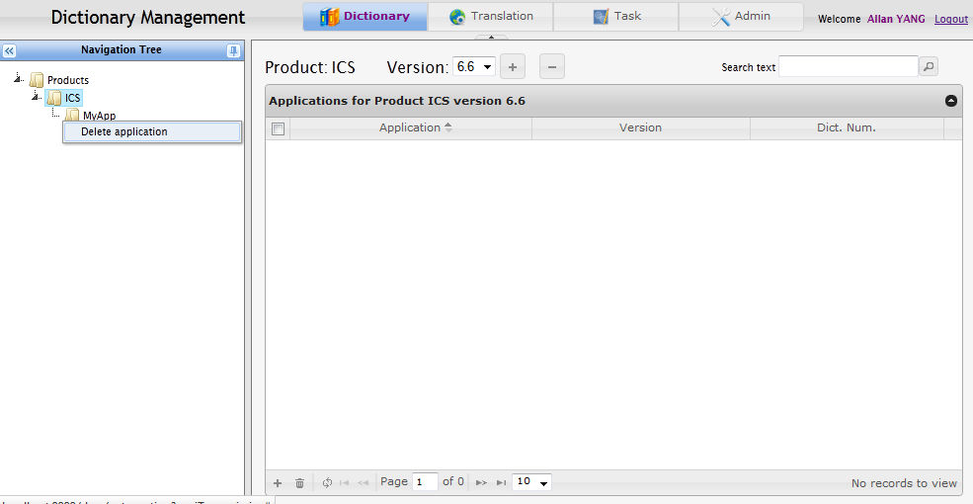
Note: Only empty application can be deleted, which means you must delete all application versions and underlying dictionaries before you delete an application.

Add an application version
Click the application name, then application version list and dictionary list will be displayed on the right side. Click “+” button to add a version.
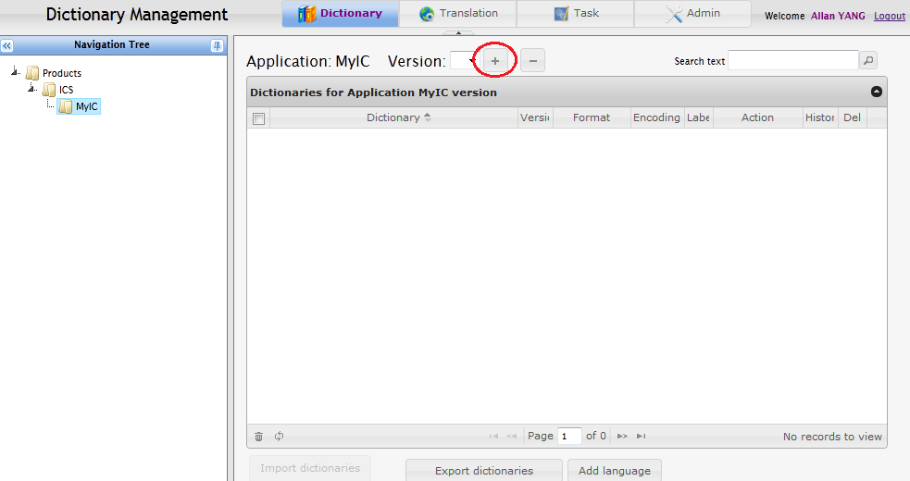
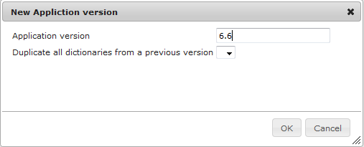
In the popup dialog, enter a version number, and select a previous version from which you want to copy dictionaries into the new version. For instance, you may want to copy all existing dictionaries in MyIC 6.6 as a start point when you create a new version 6.7. You can also create an empty version without copy dictionaries from any of the previous versions.
After adding an application version, user will be prompted to add it to a product version. In this case, application “MyIC 6.6” will be added as a part of product “ICS 6.6” if user chooses “OK”.
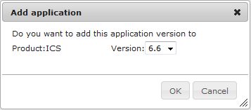

Delete an application version
Click “-” button next to version list to delete the version currently selected.
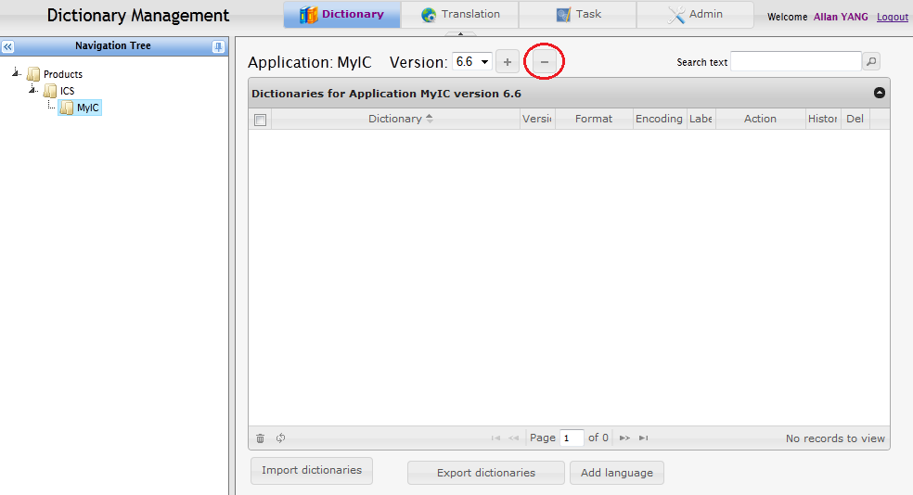
Note: Only empty application version can be deleted, which means you must delete all underlying dictionaries before you delete an application version.

Manage application list of a versioned product
Click a product name in the product tree, the product view is displayed as below.
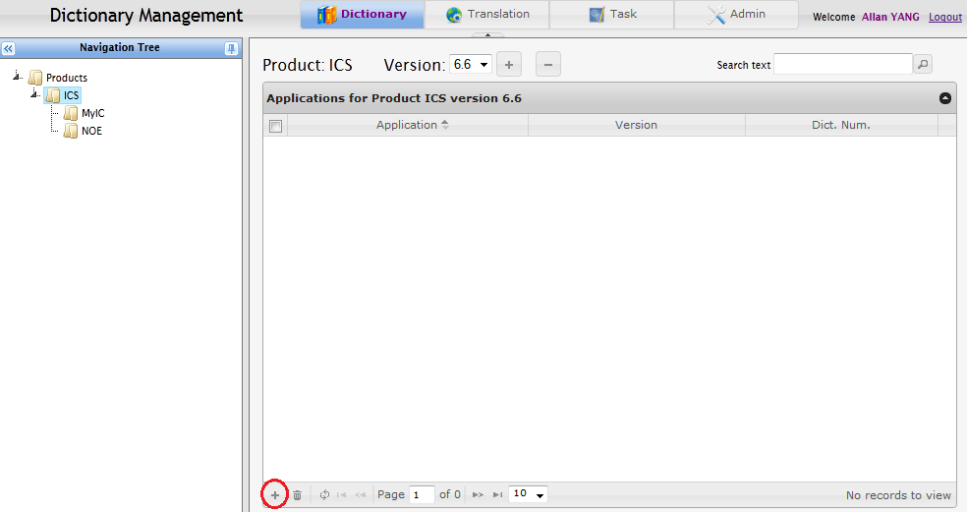
Select the product version you want to manage from the version list, e.g. “6.6”. Application list below is empty by default, even if some application names have already been added in the product tree. This is because each versioned product can be composed of a set of different applications. So it’s necessary to set application list for each versioned product after creation of product/application versions.
To add an application to the versioned product, click “+” button at the bottom of the list. Then select the application and version to add in the popup dialog.
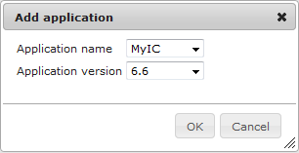
Then the selected application will be added into the versioned product and appears in application list. It’s also possible to change version of an application which is already in the list:
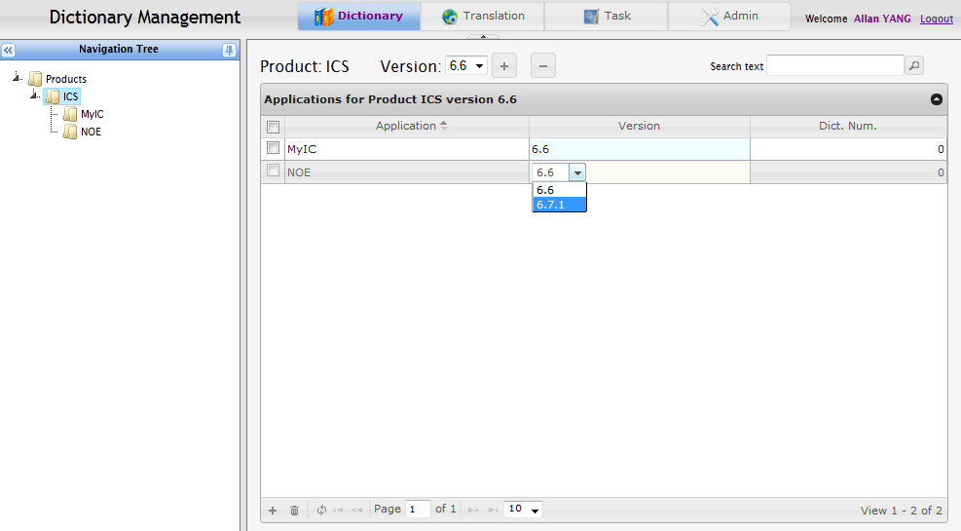
To remove an application from the versioned product, mark the application and then click button.
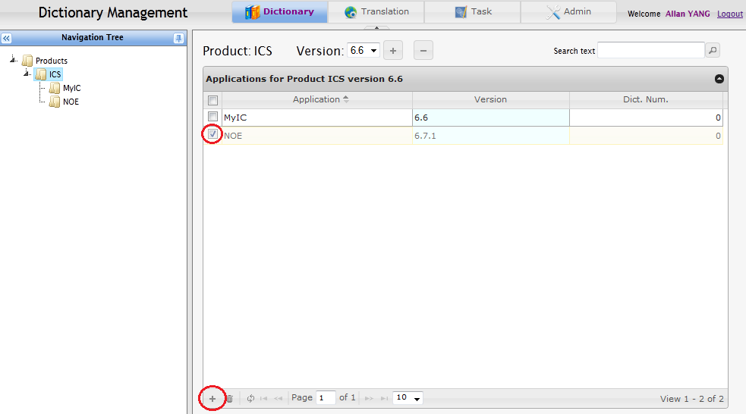
The applications removed from versioned product will not be physically deleted. They may still be added to other product versions. To physically delete an application or its version, see section 2.7 and 2.9.

Delivering application dictionaries

Supported dictionary formats
Only application dictionaries of supported formats can be delivered to DMS. Currently DMS support followings types of application dictionaries:
DCT (.dct, .dic, .dict)
DCT is a single dictionary file containing strings in different languages. It is generated and managed by GTT/DMT tools.
Text properties (.properties)
Text properties files are also known as Property Resource Bundles. They are widely used in Java applications.
XML properties (.xml)
It is an alternative to text properties in XML format.
XML labels (.xml)
Labels are represented in xml files, similar to XML properties. It is used by some ICS applications.
Dictionary conf (dictionary.conf)
Multilingual Dictionary configuration file is another type of xml dictionary, which contains strings of all languages in a single “dictionary.conf” file. It is used by some ICS applications.
XMLDict (.xdcp, .xdct)
XMLDict dictionaries are xml files managed by XMLDict tools. They are used by some OpenTouch applications.
XMLHelp (.xhlp)
XMLHelp is another type of xml dictionary, used by OXE applications.
Standard Excel (.xls, .xlsx)
A standard excel format defined in DMS for generic purpose of importing dictionary.
ICE Java Alarm (.xml)
ICE Java Alarm is another type of xml dictionary, used by ICE applications.
ACS dictionary (.txt)
A text dictionary downloaded from ACS server.
VoiceApp XML (.xml)
VoiceApp XML is another type of xml dictionary, used by VoiceApp application.
PO (.po)
PO is a text file defined and used by GNU gettext utilities. It is used by OpenTouch applications.
OTC Excel (.xls)
An excel format used by OTC PC/Android/iPhone projects. The excel file contains a well-formatted “Check display” column for purpose of translation length check.
Vital Suite (.txt)
This is a customized text format defined by Vital Suite application.
NOE String (noe_str.*, noe_stu.*)
This is a customized text format defined by NOE terminals (Docman ref: 3BA_29000_0043_PEZZA).
iOS Resource (Localizable.strings)
This is the format of resource strings for standard iOS project. It is used by some OpenTouch applications on iOS devices.
Reference: https://developer.apple.com/library/prerelease/ios/documentation/MacOSX/Conceptual/BPInternational/Introduction/Introduction.html
Android Resource (.xml)
This is the format of resource strings for standard Android project. It is used by some OpenTouch applications on Android devices.
Reference: http://developer.android.com/guide/topics/resources/string-resource.html
OTC Web (.js)
Resource strings are defined in customized javascript. It’s used by OTC Web application.
TMX (.xml)
TMX stands for Translation Memory eXchange. It’s an open standard for describing translation memory data that is being exchanged among tools and/or translation vendors. DMS supports TMX Specification V1.4b (http://www.gala-global.org/oscarStandards/tmx/tmx14b.html). It’s currently used by OTCS application which uses Sisulizer tool to deal with TMX files.

Others
Please contact DMS support team if you want to add more types of application dictionary to this support list.

Prepare dictionary package
Dictionaries are delivered to DMS by uploading them through web page. They can either be delivered separately or be packaged into a compressed file and be delivered in a batch. But files of a single dictionary must be packaged into one delivery, for example, text properties dictionary contains a set of .properties files, they must be delivered together in one compressed package.
For the moment, DMS recognizes many popular formats of compressed file such as zip, rar, 7z, gzip and so on.
Directory structure inside the delivery package decides the name of dictionary in DMS. Dictionary name is important because DMS distinguishes dictionaries by their name. If an existing dictionary is delivered again in a different name, DMS will regard it as a new dictionary and create one instead of updating the existing one.
Dictionary name is given by default in the following rules:
- If dictionary itself contains name information, e.g. XMLDict dictionary, the name is taken.
- If a dictionary is delivered alone without being packaged, dictionary name is the file name.
- If a dictionary is delivered in a compressed package, dictionary name is the relative path name of the file in compressed package. For example, if a package “call_routing_service.zip” contains a file “call_routing_service/ecccrs/crs.dic”, the dictionary name will be “call_routing_service/ecccrs/crs.dic”. So it’s important to keep the same package structure when deliver same dictionaries repeatedly.

Upload dictionary files
Once dictionary files are packaged for delivery, it’s time to upload them in the following steps:
- Click application name in Product tree to display Application view.
- Select the right application version into which you want to import dictionaries.
- Click “Import dictionaries” button and select delivery file to be imported.
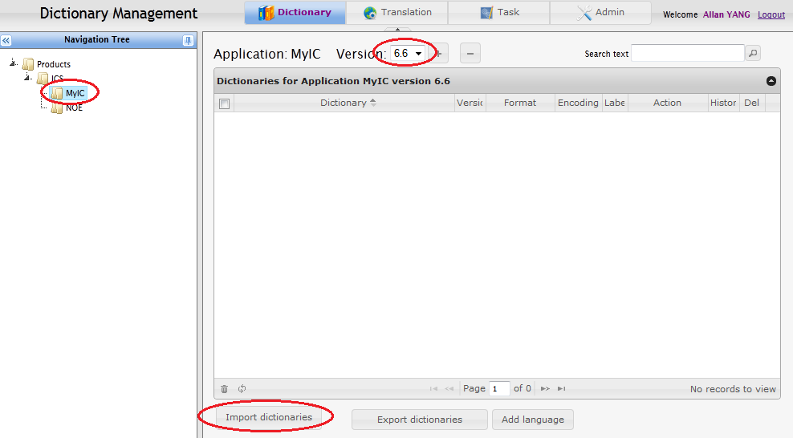
After an uploading process, a preview window is displayed if the dictionary files are parsed successfully:
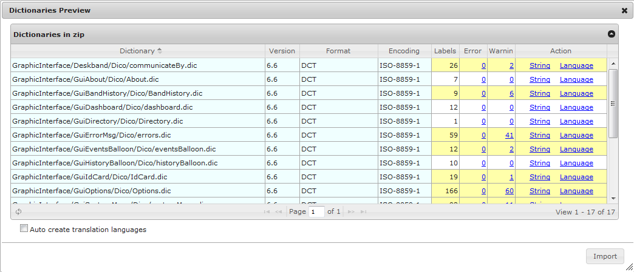
Dictionary information is listed in the grid, following fields (color ) can be modified before imported:
Dictionary: name of the dictionary, file path name is taken as value by default unless dictionary name is specified in content for some types of dictionary format, e.g. XMLDict. It should be unique in scope of the application.
Version: version number of the dictionary, current application version is taken as value by default. It can be modified if dictionary itself has a different version number.
Format: dictionary format, it’s automatically detected and no need to modify.
Encoding: dictionary encoding, it’s automatically detected and no need to modify unless there is any character encoding issue.

Change language settings
Language settings can be found and modified by clicking “Language” link in “Action” field.
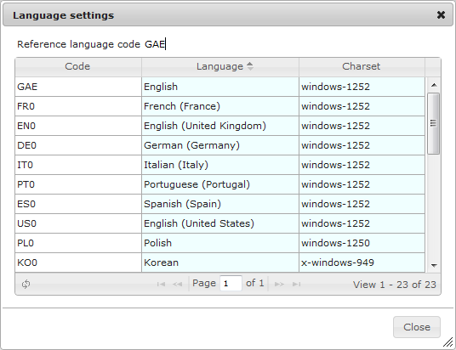
Language and Charset are automatically detected according to language code and contents of the dictionary. They can be modified if the default value is not correct or in some case, language and charset cannot be determined.
If the dictionary already exists in DMS, the language settings will be same with the existing one by default.

Change string settings
String (label) settings can be found and modified by clicking “String” link in “Action” field.
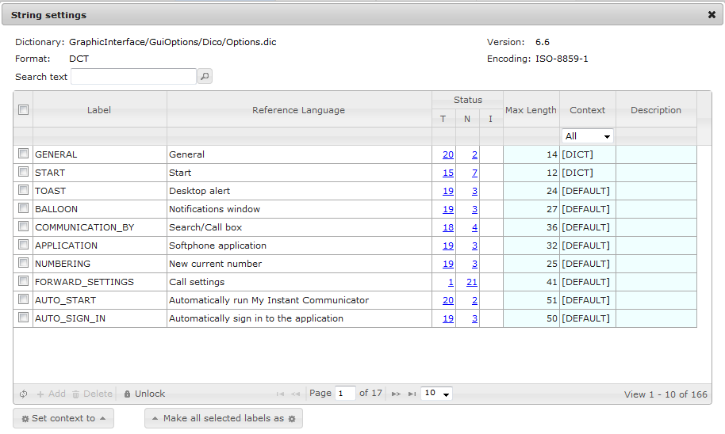
String information is listed in the grid.
Label: label key in the dictionary
Reference Language: original text of the label in English which is to be translated
Max Length: max length of the label, can be modified
Context: context of the label, can be modified, see description in the next section.
Description: description helping translator to translate the text correctly. For example: “Don’t translate ‘OpenTouch’ in the sentence.”
If the dictionary already exists in DMS, the “Max Length” and “Description” values will be same with the existing one if not provided in the current delivery.

Add/Edit/Delete labels
It’s possible to add/edit/delete labels without importing dictionary again. In previous “String settings” view, first click “Unlock” button to enable the change to labels:
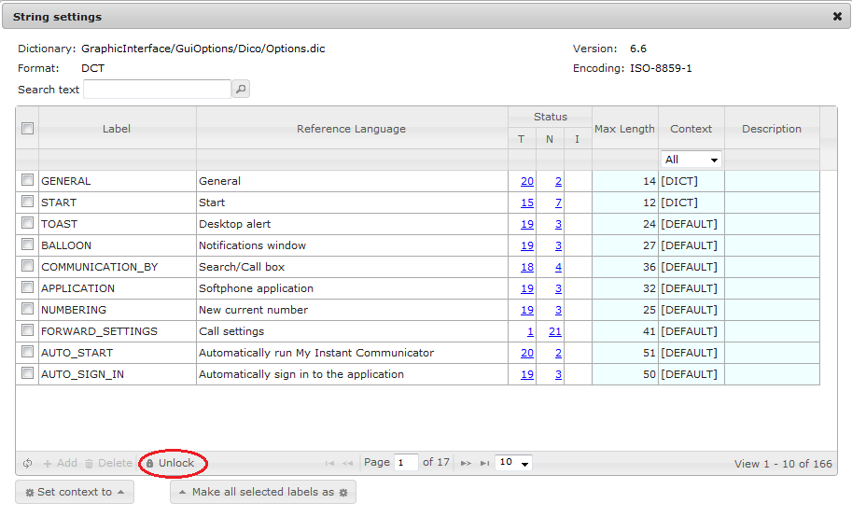
After unlocking the grid, fields “Label” and “Reference Language” become editable and “Add” & “Delete” button are enabled. Then it’s free to add, edit or delete labels in the dictionary.
WARNING: Importing the dictionary again will overwrite the changes made on labels.

About context
In order to reuse as more existing translations as possible, labels with same reference text is translated only once. Translation results are shared across dictionaries. However, sometimes same reference text in different place may have different meanings. The translation in other language can be different. For example, “Login” can refer to a “log in” action in Dictionary A, but can refer to “Account name” in Dictionary B.
Context allows people to differentiate same reference text between different meanings. In above case, the two labels should be set with different contexts, so that they will be translated respectively (In the meantime, description should be also provided to describe the difference to translator). Context name can be any keywords defined by application owner, they are case sensitive.
DMS provides some pre-defined system contexts which in syntax are surrounded by “[]”:
- [DEFAULT] – Labels with the same reference text share same translations globally. It is the default context in order to maximize translation sharing.
- [PROD] – Labels with the same reference text share same translations in scope of the product they belong to.
- [APP] – Labels with the same reference text share same translations in scope of the application they belong to.
- [DICT] – Labels with the same reference text share same translations in scope of the dictionary they belong to. It is the default context if any existing different translation than [DEFAULT] context is found.
- [LABEL] – The label doesn’t share translations with other labels. The translations are standalone for label of this context.
- [EXCLUSION] – The label doesn’t need translation.
DMS automatically decides the default context settings for label (unless some dictionaries contain context definition by themselves). It’s highly recommended to carefully check the context settings especially for those have same reference text.

Errors and warnings
In the preview grid, there are two fields indicating how many errors and warnings were found in the dictionary. User can view details by clicking the number of errors/warnings. It’s not permitted to import dictionaries when any error exists.
Possible errors and explanation:
- Unrecognized file "xxx"
The error happens when any file in the delivery package cannot be recognized as a valid dictionary. Please make sure only valid dictionary files are included in the delivery package.
- Dictionary name can't be empty.
The dictionary name is not specified.
- Dictionary version can't be empty.
The dictionary version is not specified.
- Unknown language code "xxx"
The error happens when a language code “xxx” cannot be recognized. The language must be specified manually in “Language settings”.
- Charset for language "xxx" is not defined.
The error happens when charset of a language code “xxx” cannot be automatically detected. It must be specified manually in “Language settings”.
- Duplicate label key “xxx”.
The error happens when dictionary contains more than one label with the same label key value. The dictionary must not contain duplicate label key.

Possible warnings and explanation:
- Duplicate label reference "xxx" in same context "xxx".
The warning happens when there are more than one labels in the dictionary contains same reference text and they are assigned with same context. It’s a normal case if the labels do need to share same translation. But if different translations are expected for the labels, their context must be set to different values.
- Malformed xxx characters "xxx" decoded by xxx in label "xxx".
The warning happens when a charset conversion failed, for example, trying to read an ISO-8859-1 string by UTF-8 encoding. In most case, it means an incorrect charset was specified in “Language settings”, should be corrected. However, in some cases, translation results are in wrong charset. The delivery can still proceed without changing charset settings, the labels will be set to “Not translated” status.
- Suspicious xxx characters "xxx" decoded by xxx in label "xxx".
Similar to the previous warning, but reading a string with an incorrect encoding doesn’t always report an error, although the string is in a mess. DMS tries to detect if characters in translated string are reasonable. The warning is reported in case a character of different language is found in translation, e.g. a Russian letter “Д” in a French translation. If there are many such warnings in a dictionary, the charset is likely to be set incorrectly.
- Text exceeds the max length in "xxx" of label "xxx".
The warning happens when a translation exceeds the max length definition of label.

Import dictionaries
After preview and adjust settings of delivered dictionaries, the dictionaries can be imported by clicking “Import” button.
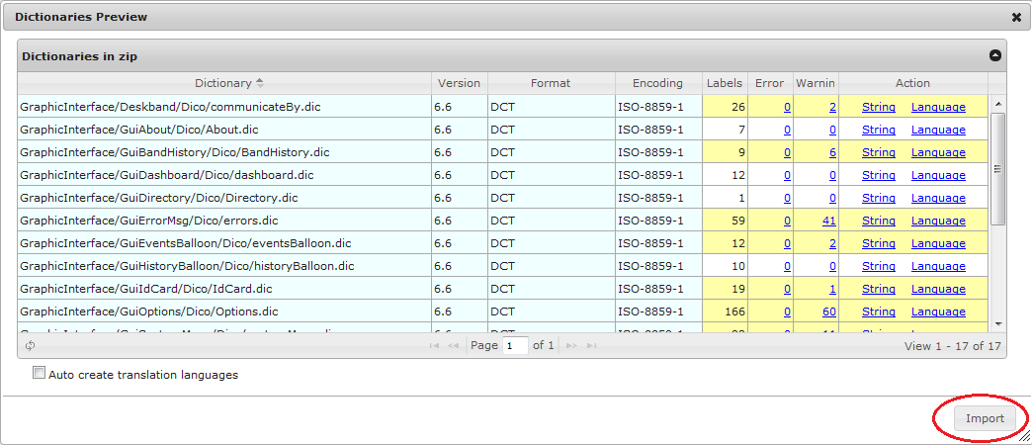
It may take a long time to import large dictionaries (about 2500 labels/min), please wait in patience.
The option “Auto create translation languages” is used to automatically add languages for dictionaries which contain only reference language such as GAE. If the option is checked, DMS will check if there is only reference language in a dictionary, if yes, then copy other languages from another dictionary in the same application to the dictionary.
Note: Import operation should be performed within 30 minutes since when the delivery file was uploaded.
After the dictionaries are imported successfully, a summary report will be shown as below:
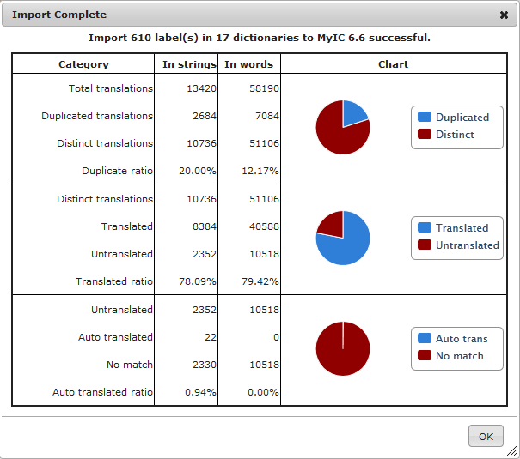
Description of items in the summary:
Total translations = total number of translations (<num of labels> * <num of languages>)
Duplicated translations = total number of duplicated translations which contain same context and reference text
Distinct translations = Total translations – Duplicated translations
Duplicate ratio = Duplicated translations / Total translations
Translated = total number of translated strings in dictionary
Untranslated = total number of untranslated strings in dictionary
Translated ratio = Translated / Distinct translations
Auto translated = Number of translations got automatically translated by existing translations in DMS
No match = Finally total number of untranslated strings which is not translated in dictionary and can’t be automatically translated by DMS
Auto translated ratio = Auto translated / Untranslated

Update existing dictionaries
After dictionaries were successfully delivered, the dictionaries can be found in Application view.
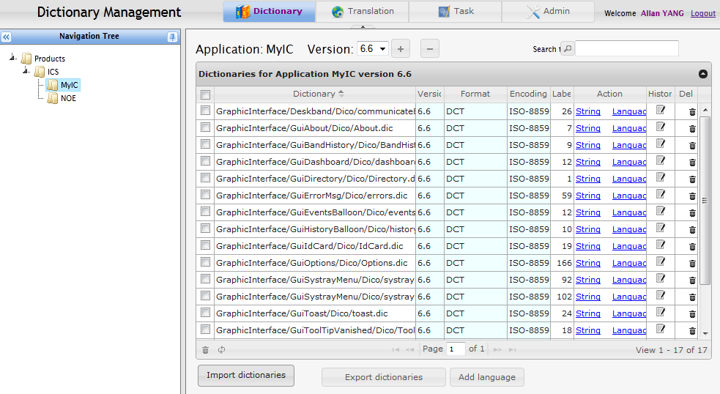
It’s possible to change dictionary version, format, encoding, string settings and language settings after delivery.
To delete dictionaries, click button in the last column, or mark dictionaries and then click button below to delete them in a batch.

Add new language to dictionaries
To add a new language to dictionaries, mark the dictionaries to which the language will be added and then click “Add language” button.
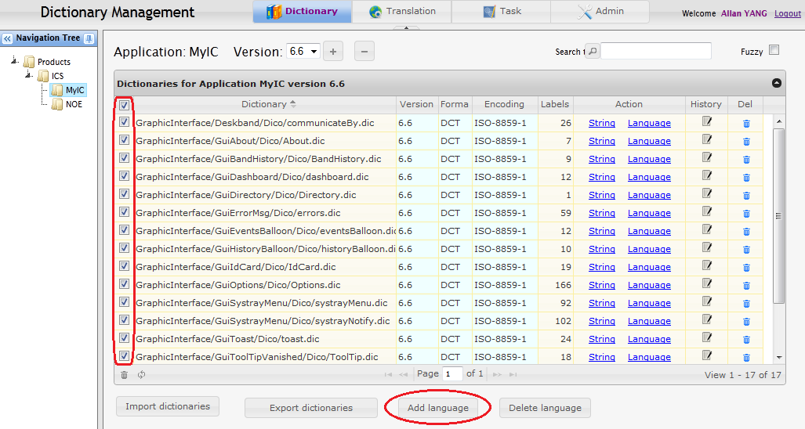
In the popup dialog, input language, charset and language code information, and then click “Add”. The new language will be added to all selected dictionaries.
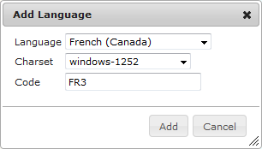
If the language to be added has different code or charset for different dictionaries, e.g. “FR3” in DCT dictionaries and “fr-CA” in property dictionaries, they must be added respectively.
On the contrary, languages can be removed from selected dictionaries by clicking “Delete language” button.

Delete dictionaries
Select dictionaries to be deleted, and then click button “”.
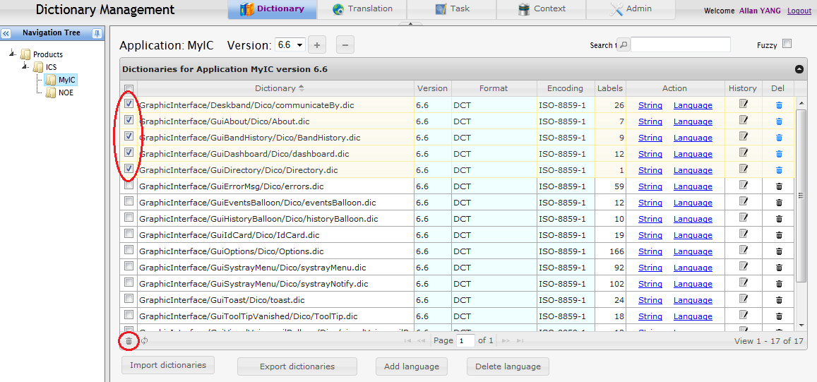
If there is any translation task associated with the selected dictionaries, you’ll be prompted to confirm deletion of the tasks.
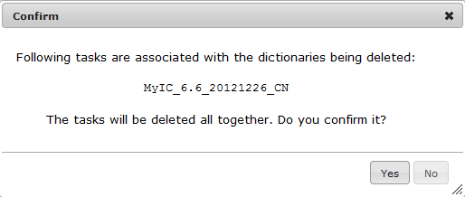

Search reference text
User can search interesting reference text in different places:
To perform a full text search, click root node “Products” in the tree panel, and then input the text to be searched:
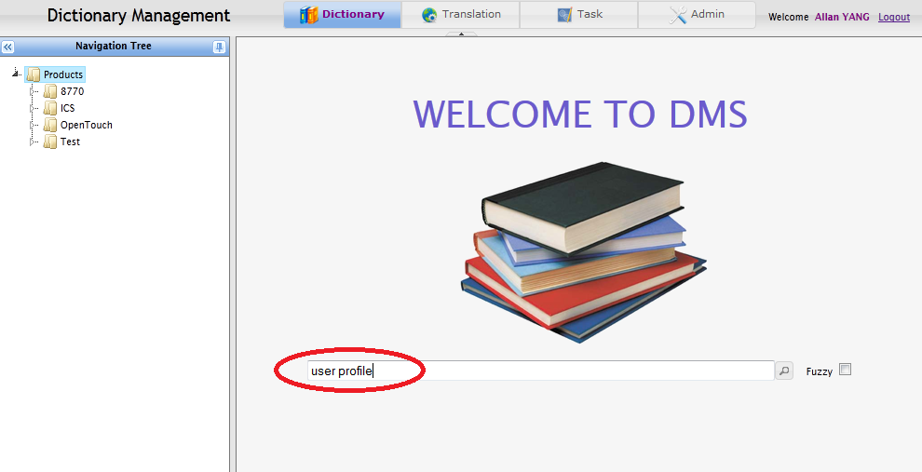
The result is grouped by “product/application/dictionary”, click “” to expand contents:
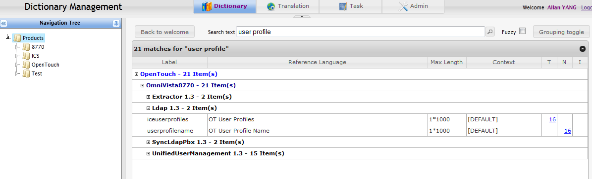
By default, only reference texts which match exactly the inputted text are displayed in the result. It’s also possible to perform a “fuzzy” search by selecting the “Fuzzy” option. When “Fuzzy” option is selected, reference texts which contain all words (or >80% similar) of inputted text are displayed.
Fuzzy query example:
“service unavailable” matches both “Service unavailable” and “Service is unavailable.”.
And even a typo “service unavaliable” matches the same.

When a specific product or application node in the tree is selected, the same text search box also exists in Product view and Application view:
Product view:
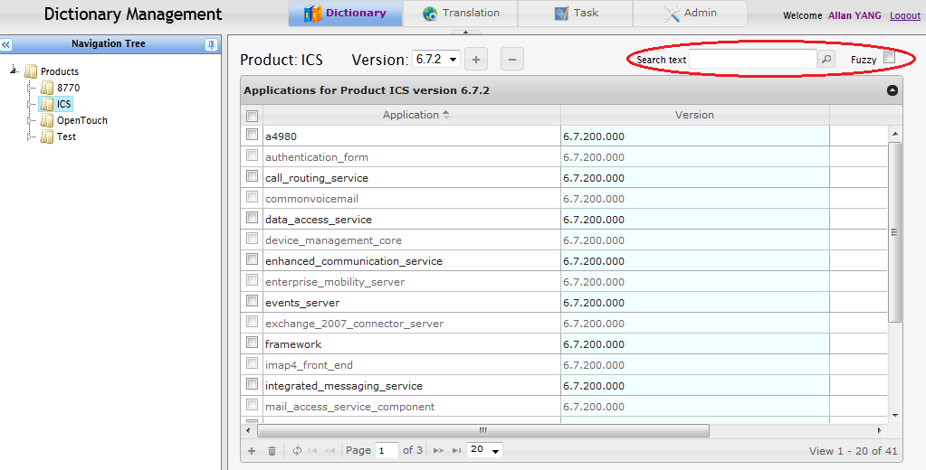
Application view:
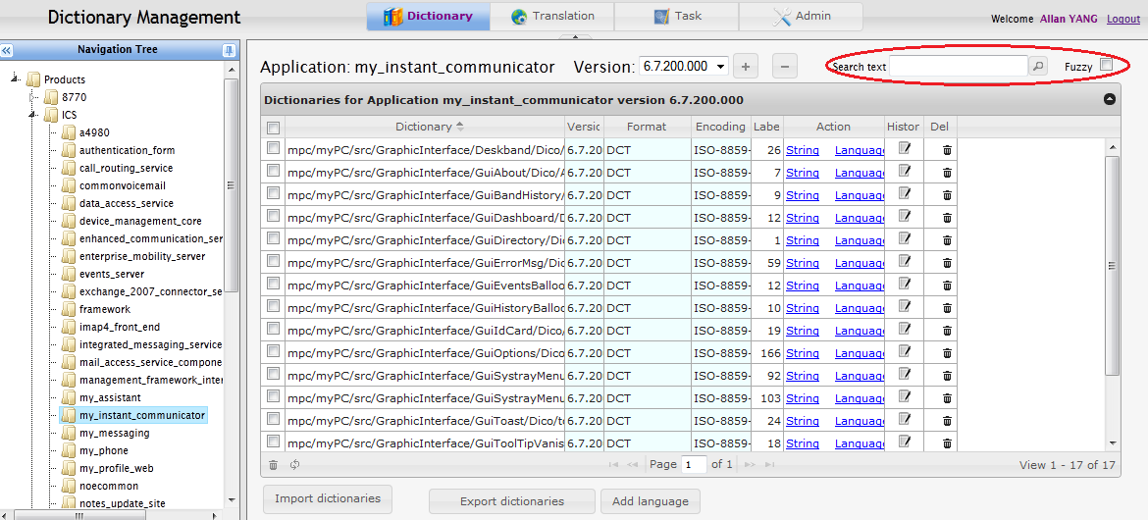
So user can perform a text search only in scope of a specific product or application.

Capitalize labels
There is a convenient way to change capitalization style of multiple labels in order to make them homogeneous. Capitalization styles are defined as below:
- ALL WORDS IN UPPER CASE – all characters are in upper case
- All Words Are Capitalized – first character of all words are in upper case
- First word is capitalized – first character of first word is in upper case
- all words in lower case – all characters are in lower case
The operation can be performed on label level:
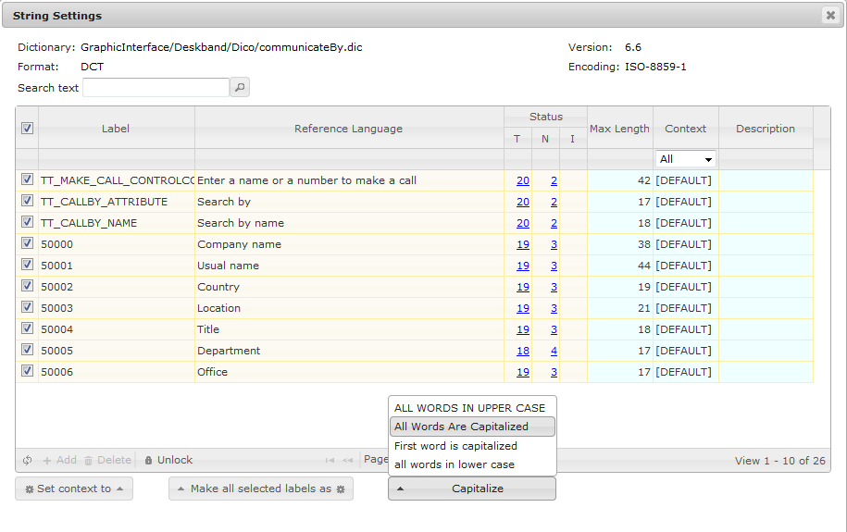
Or the entire dictionary level:
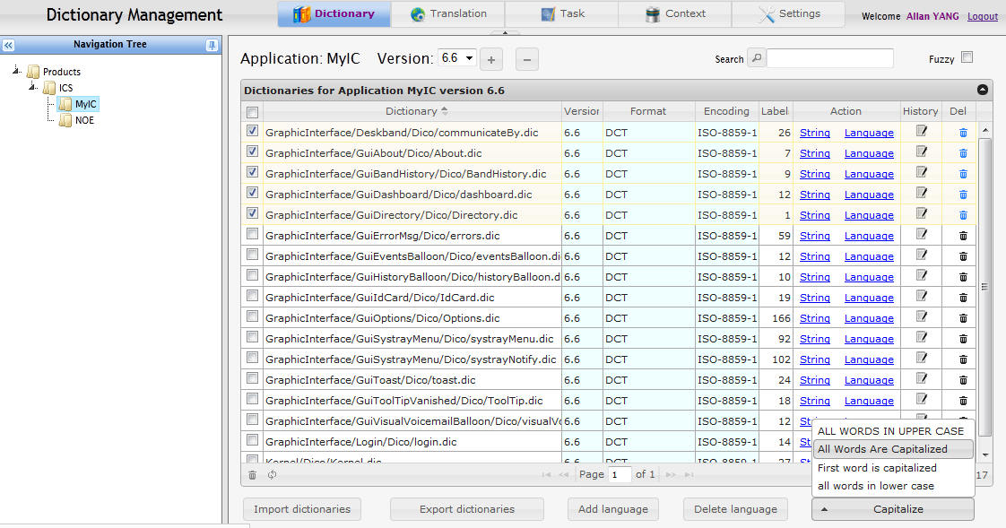
Note: All words in the string will be converted except the one defined in Glossary list (see 6.1) which is always in the same case.

Managing translations

View translation summary and details
User can view translation summary of current product/application by switching to “Translation” tab at top of the page.
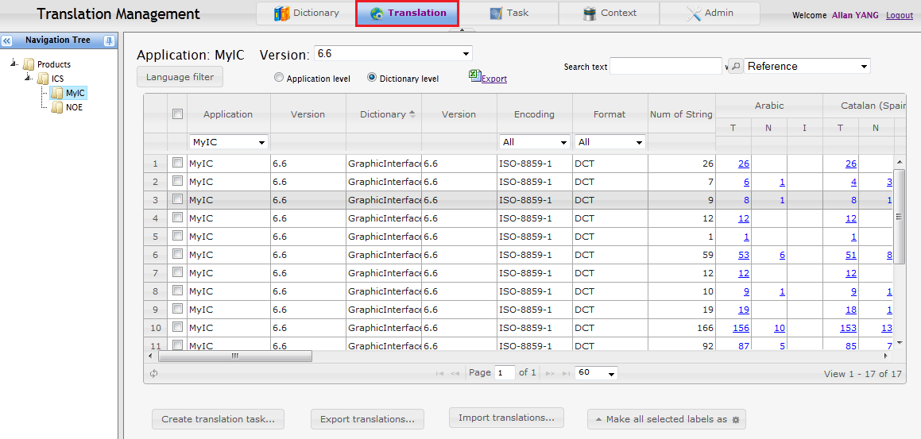
All concerned languages are included in the grid. They can be filtered by clicking “Language filter” and selecting interesting languages.
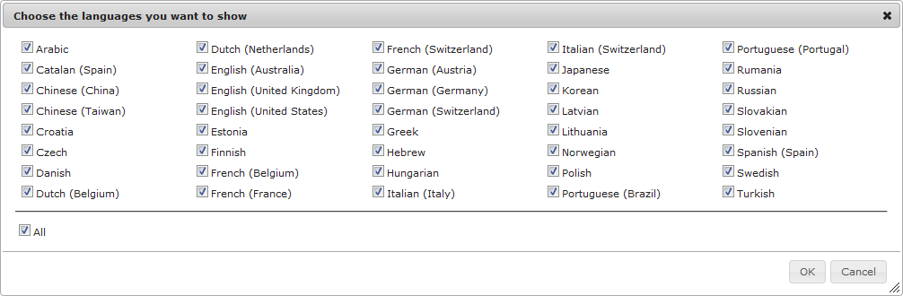
And the result can be filtered by Application, Encoding and Format values. If “Application level” is selected, the result will be summarized by application level. Content of the grid can be exported in excel format by clicking “Export” link.
Fields “T”, “N” and “I” below each languages indicate total number of translations in different status: “Translated”, “Not translated” and “In progress” respectively. Sum of T/N/I values should be equal to number of labels. Click the numbers, translation details are displayed as below:
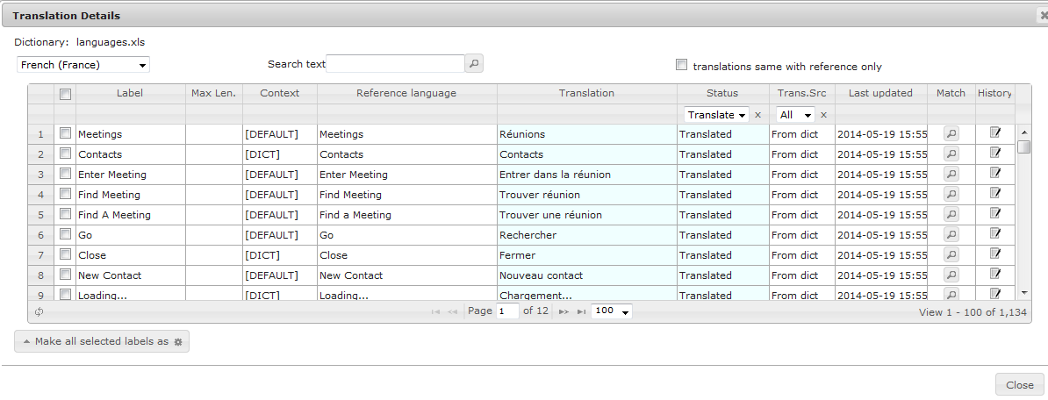
In this view, user can see translation results comparing to its original reference text.
“Trans. Src” field indicates where the current translation comes from. It can be the following values:
From dict – The translation was imported from original dictionary.
From task – The translation was imported from a translation task.
Manual – The translation was manually modified in this view.
Auto – The translation was automatically matched from other app/dict when imported or created.

Update translation and status
Translation and status can be modified in Translation Details view. There are 3 possible values for translation status:
Translated: the string is already translated, or no translation is needed
Not translated: the string is not translated
In progress: the string is not translated but has been included in a translation task
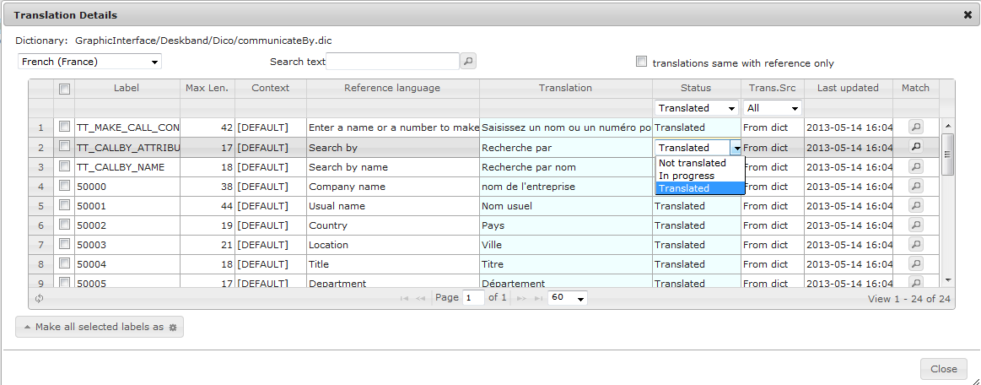
It’s possible to give a translation by matching its reference text with other label which may exist in another dictionary or application. Click “” button at the end of line, then a match result will be displayed as below:
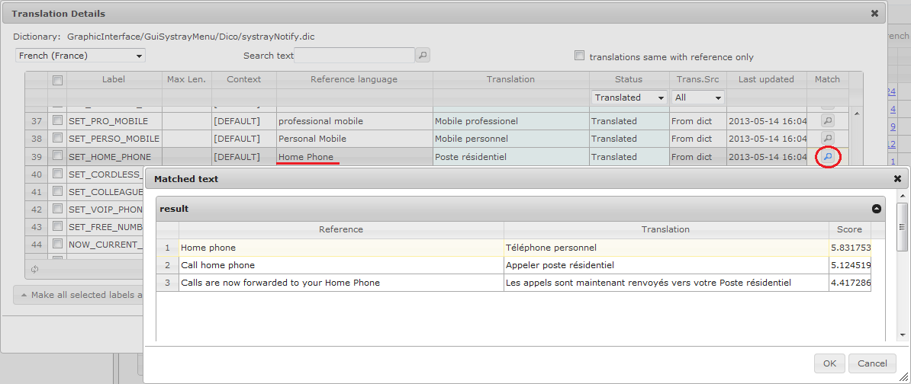
By clicking “” button at the end of line “Home Phone”, 3 similar references with their translations were found. User can decide whether to take the translation in the match results. In this case, if user select the first line of match results and then click “OK”, translation of “Home Phone” will be changed to “Téléphone personnel”.

View translation history
By clicking “” button at the end of line, user can view change history of a translation string.
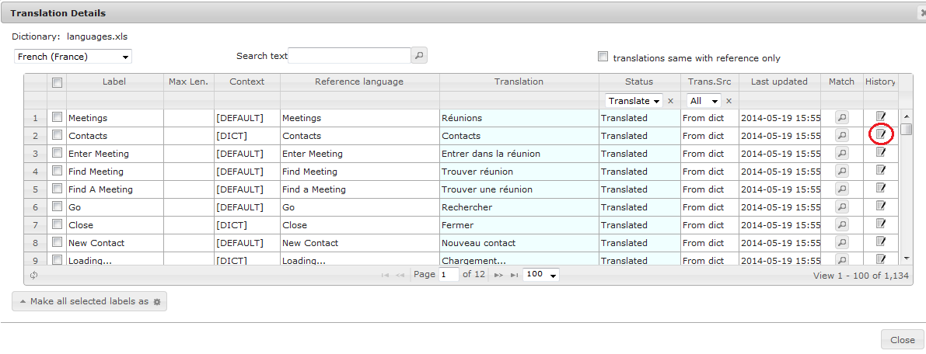
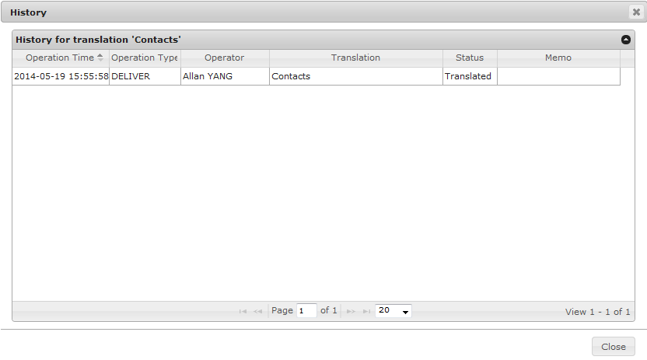

Export and import translations
Translations can be exported to an Excel file for review and update purpose. First select dictionaries and click button “Export translations…”.
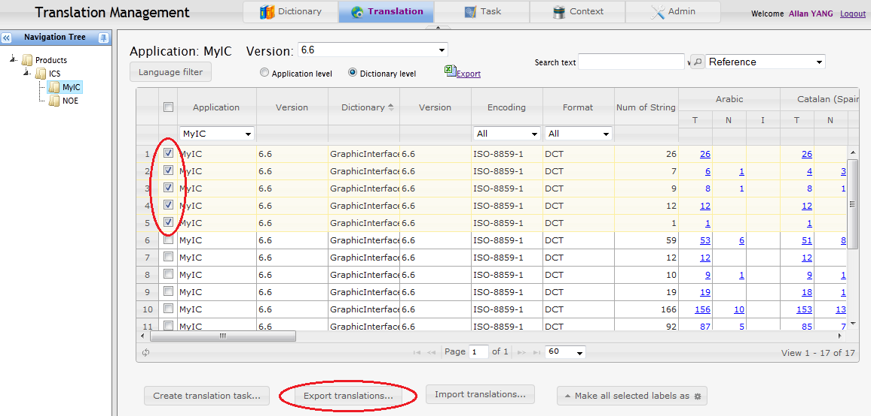
And then choose languages:
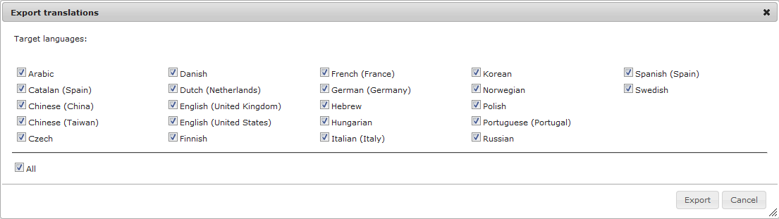
You’ll get an Excel file containing translation of all labels in the selected dictionaries, in different sheets by language.
Translation manager can review translations in the exported file and can update translations in the highlighted column below:
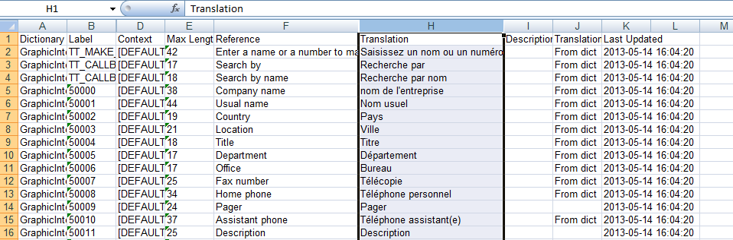
Changes in the excel file can be applied into DMS by importing the file. Click button “Import translations…” and select the modified excel file:
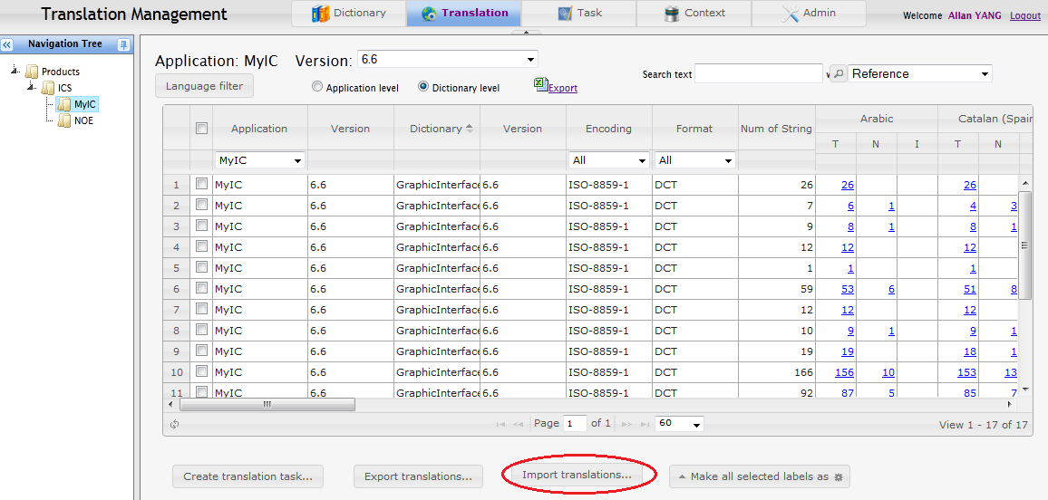

Create a translation task
In order to translate strings, translation manager is responsible to create a translation task. First, mark dictionaries to be translated, and then click “Create translation task…” button.
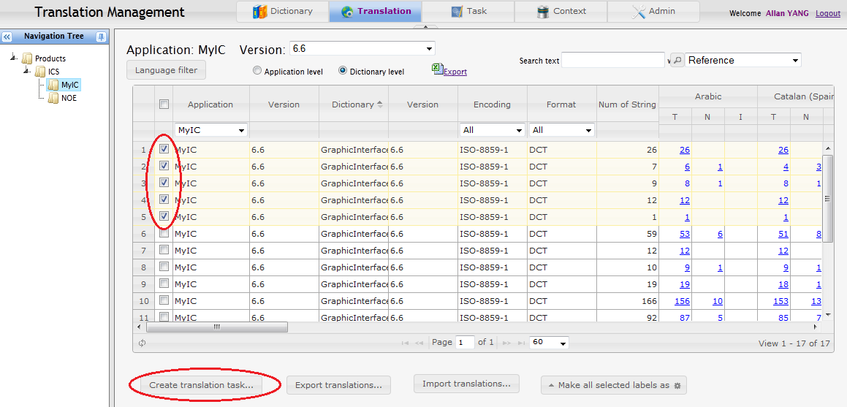
Then a task creation dialog is displayed:
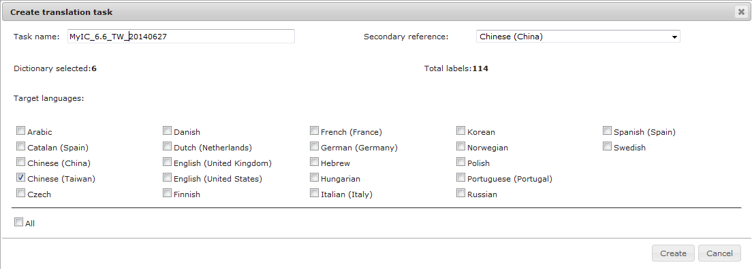
Translation manager needs to provide task name and select languages included in this task. It’s up to translation manager whether to include all languages in one task or to create separate tasks for each language. It’s possible to specify a language as “Secondary reference” besides English. This is useful when languages to be translated is similar to another translated language.
Only translation of “Not translated” status will be included in the task. The task cannot be created if all translation of selected dictionaries and languages are in “Translated” or “In progress” status. After the task is created, all included translations will be changed from “Not translated” to “In progress” status.
After creation of task, a popup prompt is displayed:
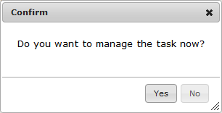
Choose “Yes” to be navigated to Task Management view immediately; choose “No” to stay in current page.

Download a translation task
After creating a task, translation manager can find it in Task Management view.
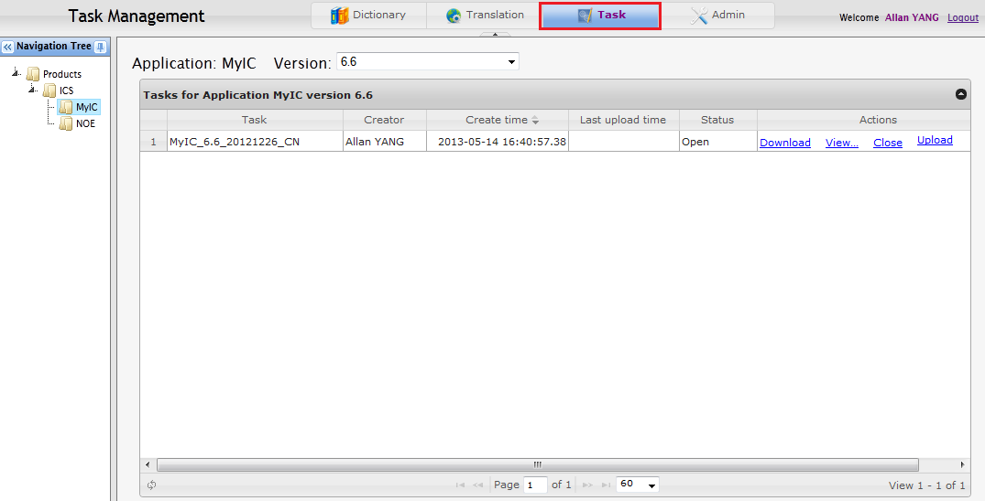
Click “Download” link to get a translation task file.

Translation task file structure
Translation task file is a compressed package with following structure:
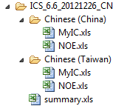
Files are organized by languages and applications, one directory for each language and one excel file for each application under the directory.
A summary file is put to the root folder of the package, showing total number labels and words to be translated for each language.
The structure of excel file is shown as below:
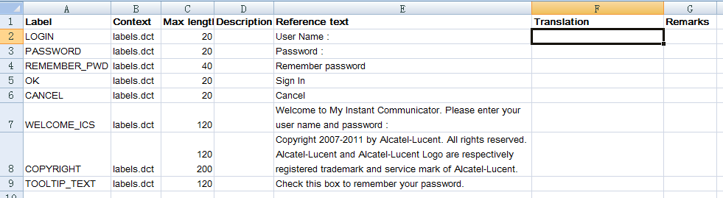
Translation results are expected to be filled in “Translation” field. If translator has any remarks, he/she can put it in “Remarks” field. All other fields should NOT be changed.
Note: For labels from OTC Android dictionary, there will be an extra column named “Display Check” for length check of translation in an intuitive way.

Upload translation results
After the translation task file got translated, translation manager is responsible to upload it to DMS. The translated excel files should be packaged to a compressed file which is organized in the same structure than the one originally downloaded for translation. Click “Upload” button to upload the result file:
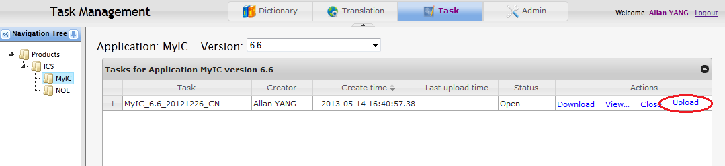
Then a translation report is displayed:
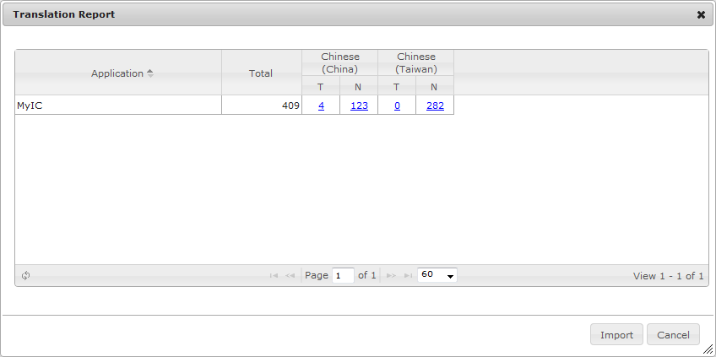
Translations different than their original reference text are regarded as “Translated” (T) while the others are “Not translated” (N). Translation details can be viewed by clicking the numbers.
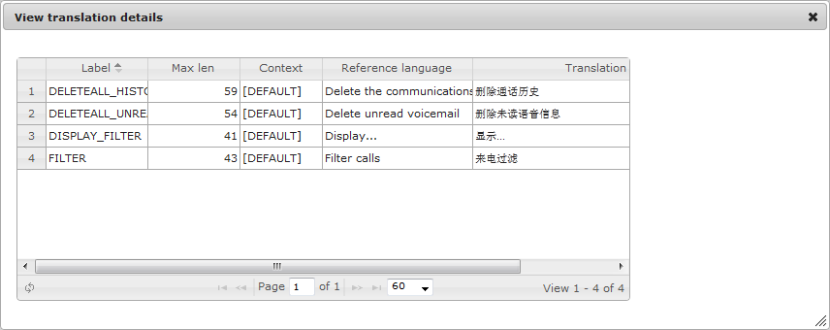
Finally, click “Import” button to apply the translation results to dictionaries. Status of strings which got translated will be changed from “In progress” to “Translated”.
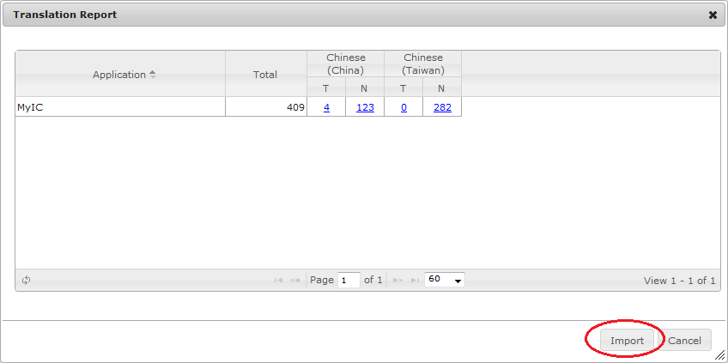
After importing translation result, following prompt is displayed:
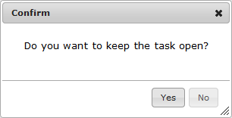
Choose “Yes” to keep the task open, translation manager can again upload and import the translation results if any update; Choose “No” to close the task. Once a task is closed, no more update is allowed and status of strings which didn’t get translated in the task are changed from “In progress” back to “Not translated” again.

Close a translation task
To close a translation task, click “Close” link in “Actions” field. After closing a task, all strings which are still in “In progress” status will be changed to “Not translated” and the task cannot be updated anymore.
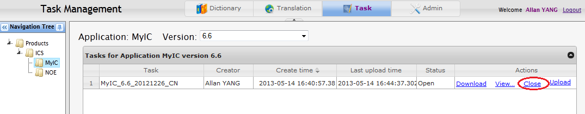

Exporting application dictionaries
Application dictionaries can be generated in Dictionary Management view. Mark the dictionaries to be generated and then click “Export dictionaries” button.
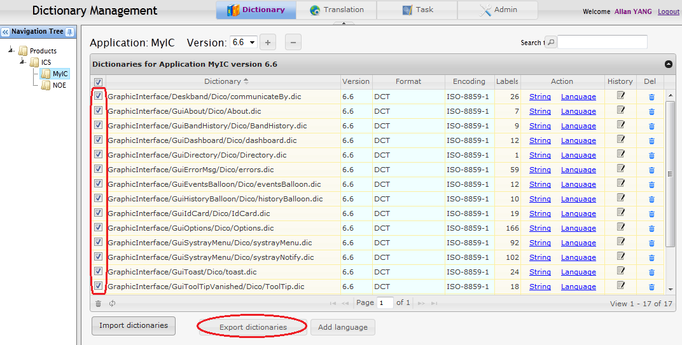
The dictionary files will be downloaded in a single zip package.
Dictionary can be generated in different format than their original when delivery. To do this, change the dictionary format before exporting, and then the application dictionaries will be generated in the required format.
Note: some type of dictionaries contain format-specific information which may prevent generating it from another type of dictionary.

Settings

Glossary
A glossary list is maintained in DMS. It affects translation activities in the following cases:
- When a label reference contains only a word in the glossary list, context of the label will be automatically set to “EXCLUSION” during importing which means the label doesn’t need translation.
- When a label reference contains any number of glossary words, the words will be always in the same case. For example: “VOIP”->”VoIP”, where “VoIP” is in the glossary list.
User can maintain the list in “Glossary” tab of the “Settings” view:
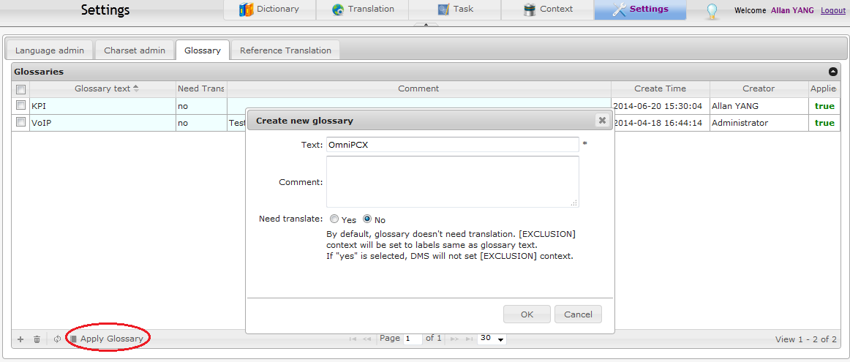
After adding or removing glossary, it’s necessary to click “Apply Glossary” button to perform a full replacement of existing labels for the new glossaries.

Reference Translation
Application owner or translation manager can maintain a “Reference Translation” list in “Settings” view as below:
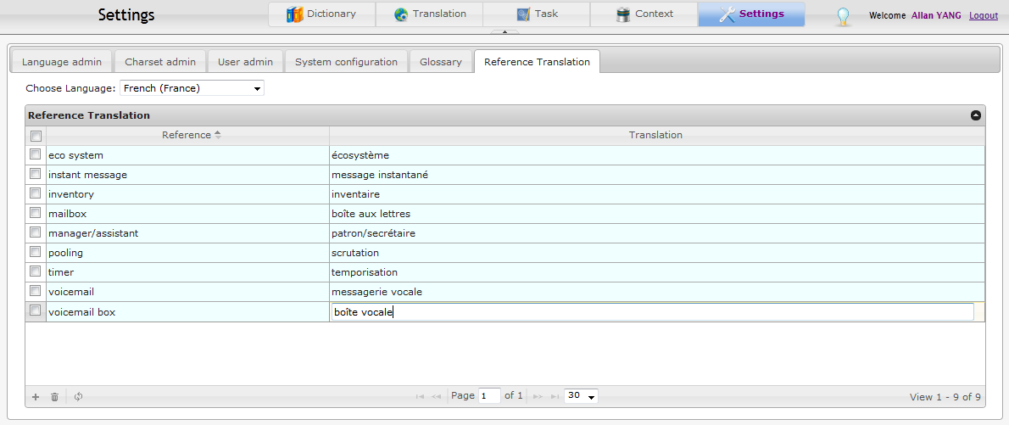
The purpose of this view is to provide other users a “preferred translation” for some references, and to make translations of different dictionary more consistent.

External Web APIs

Overview
DMS allows external system to interact with DMS via Web API. Web API can be accessed through HTTP requests. Web API takes Basic HTTP Authentication as authentication type (see http://tools.ietf.org/html/rfc1945#section-11).

Generating dictionary from DMS
Path: /api/deliver-dict
Parameters:
prod – product name
app – application name
ver – application version
HTTP response is the data stream of generated archive containing all dictionaries of the application.

Delivering dictionary into DMS
Path: /api/deliver-dict
Parameters:
prod – product name
app – application name
ver – application version
filename – name of the uploaded file
upload – data stream of uploaded file
autoCreateLang (optional) – true if want to create languages (used when deliver GAE-only files), default is false
test (optional) – true for test mode, no real action is performed, default is false
The upload file can be a compressed archive or a single dictionary file. Since there is no “preview” stage during the process, the dictionary files must not contain any error and will be imported with default settings. To validate the upload file, you can import it via DMS user interface and ensure there is no error in “Preview” window.

HTTP response is in JSON format:
status – 0 if success, otherwise error code
message – “success” or error message
report – statistics

Here below is an example of delivering dictionaries via curl tool:
curl --user cms:user4api -F "upload=@/home/dms/test.zip" "http://frcolv10lin237.pqa-collab.fr.alcatel-lucent.com/api/deliver-dict?prod=OpenTouch&app=cms&ver=2.0.5&filename=test.zip&autoCreateLang=false"
Response:
{"message":"success","report":{"dictNum":1,"distinctTranslationNum":48,"distinctTranslationWC":150,"labelNum":8,"matchedNum":10,"matchedWC":33,"translatedNum":21,"translatedWC":68,"translationNum":48,"translationWC":150,"untranslatedNum":27,"untranslatedWC":82,"warningMap":null},"status":0}

END OF DOCUMENT

